CHAPTER FOUR
ANALYTICAL MODELING AND ENGINEERING CALCULATIONS

ANALYTICAL MODELING AND ENGINEERING CALCULATIONS
The analytical modeling of the Vertical Form-Fill-Seal (VFFS) machine is predicated upon well-established principles drawn from bulk solids mechanics, screw conveyor theory, classical structural mechanics, thermodynamics, and control theory. This chapter delineates the fundamental assumptions underlying the mathematical models and establishes the comprehensive theoretical framework upon which all subsequent mechatronic calculations are constructed.

4.1 Mathematical Foundations and Assumptions

4.1.1 Fundamental Assumptions
The following assumptions are systematically employed in developing the analytical models presented herein:
- A1. Continuum Assumption —Although granular materials are inherently discrete particulate assemblies, they are treated as continuous media for the purposes of macroscopic analysis. Physical properties are accordingly represented by spatially averaged field variables, an approach well supported in powder mechanics literature.
- A2. Steady-State Operation —The analysis assumes steady-state operating conditions with constant rotational speed and uniform material feed rate. Transient effects during startup and shutdown phases are neglected. This is consistent with standard practice in screw conveyor analysis.
- A3. Isotropic Material Properties —The bulk density and internal flow properties of the granular medium are assumed to be isotropic (i.e., uniform in all spatial directions) within the auger conveying channel.
- A4. Rigid Boundary Conditions —The auger housing and supporting structural frame are assumed to be perfectly rigid, with all deformation confined to the auger shaft and flight elements. This allows decoupling of the structural analysis from the frame dynamics.
- A5. Constant Volumetric Efficiency —The volumetric efficiency factor (ηₕ) is treated as constant over the design speed range. Deviations due to slip, backflow, and aeration effects are addressed through an empirically determined correction coefficient, as recommended by the Conveyor Equipment Manufacturers Association (CEMA) guidelines.

4.1.2 Material Properties
The analytical models employ the following physicochemical properties for sodium chloride (NaCl), which constitutes the primary target material for the designed system:
- True (crystalline) density: ρₜ = 2165 kg/m³
- Loose bulk density: ρₑ = 1200–1300 kg/m³ (design value: 1300 kg/m³)
- Angle of repose: φᵣ = 30–35°
- Internal friction angle: φ = 30–45°
- Wall friction coefficient (steel): μᵧ = 0.25–0.35 (Wall friction angle φᵧ ≈ 20°)
- Unconfined yield strength: σᶜ ≈ 200 Pa
- Cohesion: c ≈ 150 Pa
These values are consistent with published data for industrial-grade sodium chloride. To evaluate the powder's flow behavior, the Mohr-Coulomb failure criterion is applied to determine the shear stress required to initiate flow:
τ = σ · tan(φ) + c (4.1)
Additionally, the flowability of the salt is evaluated using the Flow Function (FF):
FF = σ₁ / σᶜ (4.2)
Based on the principal consolidation stress (σ₁), the salt is classified as free-flowing, ensuring stable handling characteristics.

4.2 Mechanical Modeling of the Dosing System

4.2.1 Hopper Flow Modeling and Geometry Design
The analytical model of the auger filling subsystem must include the hopper and agitator assembly to ensure the stability of powder flow into the auger inlet.

Angle of repose:
The angle of repose was determined experimentally using the fixed funnel method. For a salt cone with a base radius r = 7 cm and a height of 5 cm:
θ = tan⁻¹(5/7) = 35.54° (4.3)
This experimental value(see Figure3.1) aligns with the standard range for fine table salt.
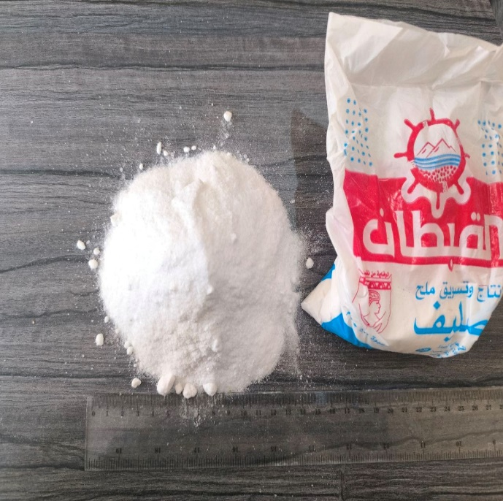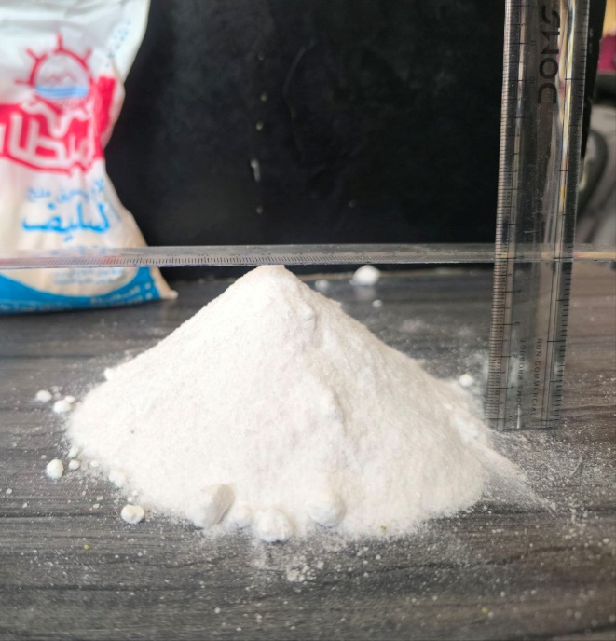

Critical Arching Diameter Calculation:
To prevent powder bridging, the hopper outlet must be larger than the critical arching diameter (Bᶜ) predicted by Jenike-based theory:
Bᶜ = H(θ) · σᶜ / (ρg) (4.4)
where:
- Bᶜ = critical arching diameter $\left(\text{m}\right)$
- H(θ) = hopper geometry factor
- σᶜ = unconfined yield strength $\left(\text{Pa}\right)$
- $ρ$ = bulk density $\left({\text{kg/m}}^{3}\right)$
- $g$ = gravitational acceleration $\left({\text{m/s}}^{2}\right)$
For a conical hopper, H(θ) ≈ 2.2. Substituting the design values:
Bᶜ = (2.2 × 200) / (1300 × 9.81) = 0.0345 m = 34.5 mm (4.5)
The selected hopper outlet diameter is Dₒᵤₜ = 65 mm. Thus, the safety factor against arching is:
SFₐᵣᶜⱼᵢₙᵏ = Dₒᵤₜ / Bᶜ = 65 / 34.5 ≈ 1.88 (4.6)

Hopper Wall Angle Requirement for Mass Flow:
A simplified Jenike design criterion is given by:
θ < (90° − φᵧ) − 5° (4.7)
where:
- $θ$ = hopper wall angle measured from horizontal
- φᵧ = wall friction angle between powder and hopper wall surface
Using the conservative upper bound φᵧ = 25°:
θₘₐₓ < (90° − 25°) − 5° = 60° (4.8)
The selected hopper wall angle is 60° from horizontal (30° from vertical). Since the required angle of inclination should be at least 35.54° + 15° = 50.54°, the 60° selection perfectly satisfies the theoretical condition for mass flow.

Hopper Geometry and Capacity Calculation:
The required hopper capacity is V = 20 L = 0.02 m³. The frustum volume is defined by:
V = (πh/3) · (R² + Rr + r²) (4.9)
where:
- $h$ = hopper height
- $R$ = top radius
- $r$ = outlet radius
With outlet radius r = 32.5 mm and wall angle 60°, solving iteratively yields:
h ≈ 0.33 m = 330 mm (4.10)
Dₜₒₚ = 2R ≈ 0.446 m = 446 mm (4.11)

Hopper Discharge Time Analysis:
The gravity discharge capability was estimated using a Beverloo-type relation for granular solids:
$\dot{M}$ = C · ρ · g¹/² · (Dₒ − kdₚ)⁵/² (4.12)
where:
- $\dot{M}$ = mass discharge rate $\left(\text{kg/s}\right)$
- $C$ = discharge coefficient
- $ρ$ = bulk density $\left({\text{kg/m}}^{3}\right)$
- $D_{o}$ = outlet diameter $\left(\text{m}\right)$
- $k$ = particle shape factor
- $d_{p}$ = mean particle diameter $\left(\text{m}\right)$
Using design values (C=0.58, k=1.5, dₚ=0.0003 m), the discharge rate is $\dot{M}$ ≈ 2.8 kg/s. The time required to discharge a 0.5 kg dose is therefore:
t = m / $\dot{M}$ = 0.5 / 2.8 ≈ 0.18 s (4.13)
This indicates the hopper is capable of feeding the auger significantly faster than the required 0.75 s fill time.

Hopper Hydrostatic Pressure Calculation:
The maximum static pressure imposed by the powder column on the hopper walls is:
P = ρgh = 1300 × 9.81 × 0.33 = 4208.5 Pa (4.14)
A design pressure of P = 4300 Pa is adopted for structural analysis.

4.2.2 Hopper-Agitator Synchronization with the VFFS Cycle
The hopper-agitator subsystem must operate in coordination with the auger and the general VFFS machine cycle. The filling and powder stabilization phases must satisfy:
T_{fill} + t_{settle} < t_{cycle}− t_{seal}
Because the hopper discharge capability is much faster than the required fill interval, the primary role of the agitator is not to increase mass flow rate, but to maintain uniform powder conditions at the auger inlet by preventing compaction, reconditioning the powder bed, and reducing local density fluctuations.
The agitator operates at approximately 30 RPM, while the auger operates at the upgraded speed of 300 RPM. Counter-rotation between these two elements generates localized shear within the powder bed and promotes highly stable feed conditions, confirming the hopper-agitator system as an active component of the high-speed dosing mechanism.

4.2.3 Auger Volumetric and Kinematic Dosing
The kinematic analysis establishes the functional relationship between auger rotational speed and material displacement rate. All calculations in this section are performed for an upgraded design throughput rate of 20 bags per minute (i.e., 20 × 500 g = 10 kg/min).

Theoretical Volumetric Flow Rate:
The theoretical volumetric displacement per revolution of a single-flight auger screw is derived from the annular geometry bounded by the outer flight diameter (D) and the central shaft diameter (Dₛ). The effective cross-sectional area of the conveying channel is given by:
A = (π/4) × (D² − Dₛ²) (4.15)
Substituting the design parameters D = 60 mm and Dₛ = 16 mm:
A = (π/4) × (0.060² − 0.016²) = 2.626 × 10⁻³ m²
The theoretical volume displaced per revolution is the product of the cross-sectional area and the screw pitch (P):
V_{th} = A × P = 2.626 × 10⁻³ × 0.060 = 1.576 × 10⁻⁴ m³/rev = 157.6 cm³/rev (4.16)
The theoretical volumetric flow rate at the design operating speed of N = 300 RPM (5 rev/s) is:
Q_{th} = V_{th} × N = 1.576 × 10⁻⁴ × 5 = 7.88 × 10⁻⁴ m³/s (4.17)

Mass Flow Rate as a Function of Bulk Density and Rotational Speed:
The actual mass flow rate accounts for the volumetric efficiency (ηᵥ), which quantifies the deviation from ideal displacement due to particle slip, backflow, and incomplete channel filling. For free-flowing granular salt, empirical data suggests ηᵥ ≈ 0.65. The effective volumetric displacement per revolution is:
V_{th} = V_{th} × ηᵥ = 157.6 × 0.65 = 102.4 cm³/rev (4.18)
The mass flow rate is then calculated from the bulk density relationship:
ṁ = V_{th} × N × ρₑ = 102.4 cm³/rev × 5 rev/s × 1.30 g/cm³ = 665.6 g/s (4.19)
For a target dose of 500 g, the requisite filling time is:
T_{fill}= m_{target} / ṁ = 500 / 665.6 = 0.75 s (4.20)

Auger Filler Engineering Calculations:
Number of Revolutions per Bag:
N_{rev} = m_{target} / m_{rev} (4.21)
For a 500 g bag with the updated m_{rev} = 0.133 kg:
N_{rev} = 0.500 / 0.133 = 3.75 revolutions
A design value of 3.95 revolutions is adopted to provide additional operational margin and accommodate volumetric efficiency variations across different material batches.
Filling Time per Bag:
T_{fill} = (N_{rev} / n) × 60 [seconds] (4.22)
At n = 300 RPM and N_{rev} = 3.75:
T_{fill} = (3.75 / 300) × 60 = 0.75 s
Motor Angular Velocity:
ω = 2πn / 60 (4.23)
For n = 300 RPM: ω ≈ 31.41 rad/s
Product | Bulk Density (kg/m³) | Angle of Repose (°) | Auger Dia. (mm) | Pitch/Dia. Ratio | RPM for 500g | Vol. Eff. (%)
Salt | 1,200 | 35 | 50 | 1.0 | 15 | 85
Sugar | 800 | 45 | 60 | 0.9 | 12 | 80
Coffee | 350 | 40 | 75 | 0.8 | 18 | 70
Table 4.1 — Auger Design Parameters by Product Type
Parameter | Salt | Sugar | Coffee
Target Weight | 500 g | 500 g | 500 g
Tolerance (±) | 5 g | 7.5 g | 10 g
Accuracy (%) | ±1.0% | ±1.5% | ±2.0%
Precision (CV%) | < 0.5% | < 0.8% | < 1.2%
Calibration Freq. | Daily | Daily | Every shift
Table 4.2 — Filling Accuracy Requirements
4.2.3.1 Target Dosing and Calibration
To maintain strict gravimetric accuracy across different material batches and varying environmental conditions, the control system utilizes a dynamic Volumetric Correction Factor (C_{V}). This factor compares the experimentally measured mass (m_{actual}) with the calculated theoretical mass (m_{theory}):
C_{V} = m_{actual} / m_{theory}
The system then automatically computes the Corrected Number of Revolutions (N_{corrected}) required to achieve the target weight:
N_{corrected} = N_{theory} · 1/ C_{V}
This adaptive calibration loop ensures that the system compensates for local density fluctuations and volumetric efficiency variations in real-time.

4.2.4 Dynamic Torque Estimation
Accurate estimation of the torque required to rotate the auger under load is essential for the proper selection of the drive motor and gearbox assembly. The total torque comprises several physically distinct components, each arising from a different resistance mechanism within the system [1][13].

Agitator Blade Torque Requirement:
The blade torque is approximated by:
T = n · τ · Aₐ · rₘ (4.24)
where:
- $T$ = blade torque $\left(\text{N.m}\right)$
- $n$ = number of blades contributing to resistance
- $τ$ = powder shear stress at blade surface $\left(\text{Pa}\right)$
- $A_{b}$ = blade projected area $\left({\text{m}}^{2}\right)$
- $r_{m}$ = mean blade action radius $\left(\text{m}\right)$
For the long blade:
- blade length $=0.2024\text{ m}$
- blade width $=0.060\text{ m}$
- $A_{b}=0.2024×0.060=0.0121 {\text{m}}^{2}$
- $r_{m}≈0.15\text{ m}$
- $τ≈150\text{ Pa}$
Thus:
$$\begin{matrix} & T_{long}=1×150×0.0121×0.15≈0.27 \left(\text{N.m}\right) & & \end{matrix}$$
For the short blade:
- blade length $=0.1062\text{ m}$
- blade width $=0.060\text{ m}$
- $A_{b}≈0.1062×0.060=0.0064 {\text{m}}^{2}$
- $r_{m}≈0.10\text{ m}$
Therefore:
$$\begin{matrix} & T_{short}=1×150×0.0064×0.10≈0.096 \left(\text{N.m}\right) & & \end{matrix}$$
For the long blade (T_{long} ≈ 0.27 N·m) and short blade (T_{short} ≈ 0.096 N·m), the total torque is:
T_{total} = T_{long} + T_{short} = 0.27 + 0.096 = 0.37 N·m (4.25)
Applying a safety factor of 2.0, the minimum design requirement is T_{design} = 0.74 N·m.

Torque Components: Powder Resistance and Friction (Auger):
The total torque required at the auger shaft is decomposed as follows:
T_{total} = T_{material} + T_{wall} + T_{bearing} + T_{inertia} (4.26)
The material transport torque is estimated using the Roberts-Rademacher formulation for screw conveyors:
T_{material} = μₛ · Fₙ · Dₘ / 2 (4.27)
Where μₛ ≈ 0.4 is the internal friction coefficient, normal force Fₙ = 6.70 N (for a 200mm column), and mean diameter Dₘ = 38 mm.
T_{material} = (0.4 × 6.70 × 0.038) / 2 = 0.051 N·m
The wall friction torque (T_{wall}) evaluates to 0.060 N·m.

Motor Sizing and Gear Ratio Optimization:
Including bearing friction (estimated at 0.5 N·m) and angular acceleration torque (2.0 N·m), the total shaft torque is:
T_{total} = 0.051 + 0.060 + 0.5 + 2.0 = 2.61 N·m (4.28)
Incorporating a safety factor of 1.5 and a compaction correction factor of 5, the design torque is:
T_{design} = 2.61 × 1.5 × 5 = 19.6 N·m ≈ 20 N·m (4.29)
With a 20:1 planetary gearbox (η_{gear} = 0.97), the required motor output torque is:
Tₘₒₜₒᵣ = T_{design} / (i × η_{gear}) = 20 / (20 × 0.97) = 1.03 N·m (4.30)
The selected Panasonic MSMF042L1U servo motor provides 1.27 N·m rated torque and 3.82 N·m peak torque, yielding an adequate margin for all anticipated operating conditions [14].
The mechanical power requirement is computed as:
P = T_{design} × ω = 20 × (2π × 135/60) = 283 W (4.31)
The 400 W rated motor thus provides a power margin of approximately 41% above the calculated demand, ensuring reliable operation under transient and peak loading scenarios [15].

4.2.5 Structural Analysis of the Auger Shaft
The auger shaft must withstand the applied torques and transverse loads without incurring excessive stress or deflection.

Torsional Stress on the Auger Shaft:
The torsional shear stress in a solid circular shaft subjected to an applied torque T is given by:
τ = T · r / J (4.31)
For a solid circular cross-section Dₛ = 16 mm:
J = (π × Dₛ⁴) / 32 = (π × 0.016⁴) / 32 = 6.434 × 10⁻⁹ m⁴ (4.32)
The maximum shear stress under the design torque T = 20 N·m is:
τₘₐₓ = (20 × 0.008) / (6.434 × 10⁻⁹) = 24.9 MPa (4.33)
For AISI 316L stainless steel, the shear yield strength according to the von Mises criterion is τᵧ = 118.4 MPa. The factor of safety against torsional yielding is therefore:
FS = τᵧ / τₘₐₓ = 118.4 / 24.9 = 4.76 (4.34)
This substantial safety factor confirms that the shaft will not yield.

Deflection and Critical Speed Analysis:
The maximum deflection at the free end is estimated using Euler-Bernoulli beam theory:
δₘₐₓ = F · L³ / (3 · E · I) (4.35)
Substituting load (F=50 N), length (L=280 mm), and Modulus (E=193 GPa), we obtain:
δₘₐₓ = (50 × 0.280³) / (3 × 193 × 10⁹ × 3.217 × 10⁻⁹) = 0.59 mm (4.36)
Finite Element Analysis (FEA) results indicate an actual maximum deflection of only 0.0021 mm, confirming that the design provides substantial rigidity.

Critical Speed Analysis:
The first critical speed for the cantilever configuration is expressed as:
ωₙ = √(k / mᵉᵐ) (4.37)
With stiffness k = 8.49 × 10⁴ N/m and equivalent mass mᵉᵐ = 0.5 kg:
ωₙ = √(8.49 × 10⁴ / 0.5) = 412 rad/s = 3934 RPM (4.38)
The high-speed operating parameter of 300 RPM represents only 7.6% of the first critical speed, providing an exceptionally large margin of safety against resonant vibration.
z

4.3 Kinematics and Dynamics of Packaging Mechanisms
This section presents the governing equations for film transport kinematics and thermal sealing thermodynamics, both of which are critical to achieving consistent bag formation at the specified throughput rate of 20 bags per minute.

4.3.1 Film Unwinding and Pulling System
The film feeding mechanism requires overcoming the rotational inertia of the film roll and the kinetic friction along the forming tube. The dynamic tension required to unwind the film without tearing it is calculated based on the linear velocity of the pulling belts. The pulling belts must apply a tangential force (Fₜ) sufficient to unroll the film, which determines the required torque for the stepper or servo motors driving the belts.
Film Linear Velocity
The linear velocity of the packaging film is determined by the product of the bag length and the production rate [22]:
$$vf = (Lbag × Nbags) / 60 (4.39)$$
where $Lbag = 0.25 m$ (for a 500 g package) and $Nbags$ is the number of bags produced per minute (range: 12–30 bags/min).
At the design throughput of 20 bags/min:
$vf = (0.25 × 20) / 60 = 0.0833 m/s$ (4.40)
For reference, the boundary velocities across the full operating range are:
$$vmin = (12 × 0.25) / 60 = 0.050 m/s$$
$$vmax = (30 × 0.25) / 60 = 0.125 m/s$$
Required Film Pulling Force
The total pulling force on the film web comprises inertial, frictional, and tension components [22]:
$Fpull = m·a + Ffriction + Ftension$ (4.41)
where Ffriction = μ × N (friction force with μ = 0.3 for plastic film on steel guides), and Ftension represents the required web tension (50–100 N) [23].
Film Tensile Stress
The tensile stress induced in the film is:
$σ = F / A = F / (t × w)$ (4.42)
where $t = 0.06 mm$ (film thickness) and w = 320 mm (film width).
Maximum Allowable Stress
$Qmax = σyield / SF$ (4.43)
where $σyield = 20-30 MPa$ (polyethylene yield stress [24]) and SF = 2.5.
The film feed mechanism utilizes a stepper motor with the following design calculations:
Distance per Revolution:
lrev = π × D₁ = π×60= 188.5 mm/rev (4.44)
Number of Revolutions per Bag:
N=188.5220​=1.17 rev (4.45)
Motor Speed:
n = $\frac{1.17}{0.6}$​×60 =117 RPM (4.46)
Force Load
$F=mg=3×9.81=29.43\text{ N}$ (4.47)
Load Torque:
Radius = 60 / 2 = 30 mm = 0.03 m
TL = Fl × D/2 = 29.43×0.03 = 0.88 N·m (4.48)
Required Torque (with safety factor of 2):
Trequired = (0.88+0.1)×2=1.96N·m (4.49){“

4.3.2 Sealing Jaws Mechanism
The actuation of the horizontal and vertical sealing jaws involves applying sufficient mechanical pressure to fuse the thermoplastic layers of the packaging film. Whether pneumatically or electromechanically driven, the required clamping force (F_{seal}) must be uniformly distributed across the sealing surface to prevent micro-leaks, ensuring the structural integrity of the 500g salt bags during subsequent handling and transportation.
Required Sealing Force
$Fseal = Pseal × Aseal$ (4.50)
where $Pseal = 2-4 bar (200-400 kPa)$ is the sealing pressure, and $Aseal = jaw length × seal width = 150 × 5 = 750 mm²$ [25]. At the maximum sealing pressure:
$$Fseal = 400 × 10³ × 750 × 10⁻⁶ = 300 N$$

4.4 Thermodynamic Modeling of the Sealing System

4.4.1 Heat Transfer in Sealing Jaws
The thermal modeling of the sealing process involves transient heat conduction from the metal jaws into the polymer film. According to Fourier's law of heat conduction, the thermal resistance of the film dictates the required contact time. The jaws must maintain a consistent surface temperature profile despite the continuous introduction of room-temperature film.
Conductive Heat Transfer
The heat transferred through the film during sealing is governed by Fourier's law of conduction [26]:
Q = (k × A × ΔT / d) × t (4.52)
where:
k = Film thermal conductivity = 0.33 $W/(m·K)$, A = Contact area = 750 mm²
ΔT = Temperature differential = 140°C − 25°C = 115°C, d = Film thickness = 0.06 mm
t = Sealing time (s)
Optimal Sealing Temperature
$Tseal = Tmelt + 20°C$ (4.34)
where $Tmelt = 120-130°C$ for polyethylene, yielding $Tseal = 140-150°$C [27].

4.4.2 Heater Power Sizing
To maintain the required sealing temperature (150°C – 180°C) at a production rate of 20 bags/min, the electrical heaters embedded in the jaws must supply sufficient thermal energy (qₜⱼₐₗ). The required wattage is calculated by summing the energy absorbed by the plastic film per cycle and the continuous convective and radiant heat losses to the surrounding environment.
Energy Required for Sealing
$Eseal = m × Cp × ΔT$ (4.51)
where:
m = Mass of sealing zone = ρ × V = 920 × (750 × 0.06 × 10⁻⁹) = 4.14 × 10⁻⁵ kg (0.041 g)
Cp = Specific heat capacity of polyethylene = 2.3 kJ$/(kg·K)$ [24]

4.5 Electrical Calculations and Actuator Sizing

4.5.1 Motor Selection and Inertia Matching
The mechanical power requirement for the auger at the upgraded speed of 300 RPM is computed as:
P = T × ω = 20 × (2π × 300/60) = 628.3 W (4.39)
A 750 W rated servo motor is therefore selected to provide a power margin of approximately 19% above the calculated demand. Additional motors, including the agitator drive and film pulling actuators, are similarly sized by matching the load inertia to the rotor inertia to ensure rapid dynamic response.

4.5.2 Power Supply and Consumption
The overall electrical infrastructure is designed to accommodate the sum of all steady-state and peak transient loads. The total power consumption (Pₜⱼₐₗ) incorporates the auger servo, pulling motors, jaw heaters, and control electronics. Industrial-grade power supplies and appropriate safety breakers are sized to handle peak inrush currents during the simultaneous actuation of heating elements and servomotors.

4.6 Control System Architecture and Signal Processing
Prior to embedded C++ firmware implementation, mechanical and thermodynamic behaviors were mathematically modeled to configure deterministic kinematic trajectories and dynamic thermal controls within the ESP32 architecture.

4.6.1 Kinematics of Precision Actuation Systems
Deterministic execution of servo and stepper motors governs precise salt dosing and film advancement [28]. The governing kinematics are derived as follows:

A. Auger Motor (Filling Mechanism)
Dispensing a 500g salt dose requires exactly 4 auger revolutions at 300 RPM [28]. The Panasonic MINAS A6 servo system utilizes a 23-bit absolute encoder yielding a native resolution of $P_native$ = 8,388,608 pulses/rev. To reconcile the ESP32's pulse-generation limits with this ultra-high fidelity, the driver’s Electronic Gear Ratio (EGR) scales the logical command resolution to a target 10,000 Pulses Per Revolution (PPR):
$$EGR = P_native / PPR_target = 8,388,608 / 10,000$$
For this 10,000 PPR interface, the total displacement command ($P_auger$) and the pulse frequency ($f_{pulse}$) required to achieve 300 RPM are calculated as [29]:
$$P_auger = Revolutions x PPR_target = 4 x 10000 = 40,000 pulses$$
To generate the required operational speed, the fundamental command pulse frequency $(f_p)$ is derived from the RPM relation [29]:
$$f_p = (N x PPR_target) / 60 = (300 x 10000) / 60 = 50,000 Hz$$
To enable asynchronous, non-blocking execution via the ESP32’s hardware Remote Control (RMT) module, this frequency dictates a microsecond pulse delay interval ($\Delta t$) [30]:
$$t_d (microseconds) = 1,000,000 / f_p = 1,000,000 / 50000 = 20 microseconds$$
B. Pull Motor (Film Advance Mechanism)
The film advancement system pulls a continuous film to create a specific bag length (L = 220 mm) using a drive roller diameter of D = 60mm [28].
The linear travel per revolution equals the roller circumference (C) [28]:
C = pi x D = 3.14159 x 60 $approx$ 188.50 mm/rev
To pull a target length of L = 220 mm, the required angular displacement (N_{rev}) and the corresponding ESP32 pulse count (P_{pull}) at 200 PPR are [29]:
N_{rev}= L / C = 220 / 188.50 $approx$ 1.17 Rev
$P_pull = Revolutions_pull$ x PPR = 1.17 x 200 $approx$ 234 pulses

4.6.2 PID Temperature Control Modeling
The sealing jaw was mathematically modeled as a lumped-capacitance thermodynamic system [32]. The rate of temperature change in the stainless-steel jaw$(m = 1 kg, c_p = 500 J/kg.K)$ is governed by the fundamental energy balance equation [31]:
$$m c_p dT/dt = Q_in - Q_cond - Q_conv$$
Where $Q_in$ represents the heat supplied by the 400W heating element via the Solid State Relay. The heat losses are modeled utilizing Fourier's Law for conduction to the machine frame and Newton's Law of Cooling for convection to the ambient air [31]:
$$Q_loss = (k A_cond / L_cond)(T - T_amb) + h A_conv(T - T_amb)$$
By utilizing the designated physical parameters $(k = 20 W/m.K, h = 20 W/m^2.K$) alongside empirical open-loop step response data processed via the MATLAB System Identification Toolbox, the continuous-time First-Order transfer function G(s) was derived [32]:
G(s) = (218.2 / (272.7s + 1))
This mathematical representation confirms the system's dominant thermal inertia (tau = 272.7 s) and quantifies the physical transport delay (theta = 2 s) between the heater activation and the thermocouple detection [32].
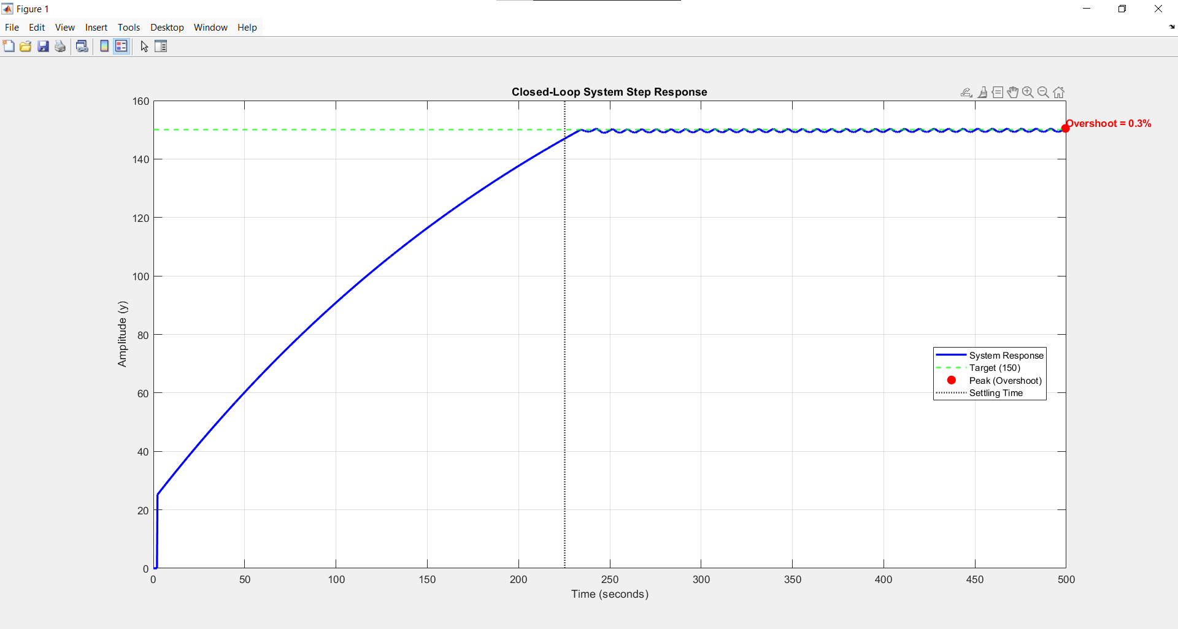
Figure:4.7.3 Experimental closed-loop response used for system identification.

4.6.3 Discrete PID Control and Digital Stability
Because the ESP32 microcontroller processes the control algorithm digitally within a discrete time domain, the continuous PID equation required discretization. Utilizing the Forward Euler approximation for both the integral and derivative terms, the control effort u(k) at sample instance k is calculated as [33]:
$$u(k) = K_p e(k) + K_i T_s sum_j=0^k e(j) + K_d (e(k) - e(k-1)) / T_s$$
For practical implementation of the derivative filter, digital stability must be mathematically guaranteed. The pole of the discrete filter must remain strictly inside the unit circle, yielding the condition$: |1 - N . T_s| < 1$ [33].
With a strict thermal sample time of $T_s = 1 s,$ applying a standard high filter coefficient (e.g., $N = 100$) results in an unstable pole at $|1 - 100| = |-99|$, leading to severe instability and control signal ringing [33]. Therefore, the coefficient was mathematically restricted to $N = 1$, safely shifting the pole to the origin $(|1-1|=0)$ and guaranteeing absolute digital stability for the time-proportional thermal control loop [33].

4.6.3 Microcontroller Processing Requirements
The central processing unit must execute multiple critical tasks simultaneously. Utilizing a Real-Time Operating System (RTOS), the microcontroller orchestrates the high-frequency pulse generation for the servo motors, reads analog sensor data, updates the HMI, and manages safety interlocks without task starvation or execution delays.

4.7 Overall VFFS System Synchronization

4.7.1 Cycle Timing and In-Flight Material Compensation
At a design throughput of 20 bags per minute, the total cycle time available per bag is:
T_{cycle} = 60 / 20 = 3.00 s/bag
By leveraging the hardware concurrency capabilities of the ESP32 microcontroller, the control logic was optimized to execute the volumetric dosing phase in parallel with the thermal sealing phase. This concurrency significantly reduces the total active cycle time. The chronological execution sequence is detailed in Table 4.1.
Table 4.1: Operational Timing Sequence for a Single 500g Cycle
Phase | Machine Action / Task |  | Active Duration $(ms)$ |  | Cumulative Time $(ms)$
1 |  | Film Pulling  ($High-speed$) |  | 600 |  | 600
2 |  | Film Pulling  (Search speed) |  | 400 |  | 1000
3 |  | Signal Verification & Halt |  | 20 |  | 1020
4 |  | Valve Response Latency |  | 31 |  | 1051
5 |  | Sealing Jaw Travel |  | 150 |  | 1201
6 |  | Thermal Sealing Dwell |  | 800 |  | 2001
7 |  | Volumetric Dosing |  | 800 (Concurrent) |  | 2001
8 |  | Pneumatic Cutting |  | 100 |  | 2101
9 |  | Jaw Release & Retraction |  | 181 |  | 2282
Total |  | Total Active Cycle Time |  | - |  | $$2282 ms$$
Table 4.1: Operational Timing Sequence for a Single 500g Cycle.

4.8 Summary of Analytical Results
Table 4.2 consolidates the key analytical predictions for the VFFS auger filling system operating at a design throughput of 20 bags per minute:
Table 4.2 — Summary of Analytical Predictions for VFFS Auger Filling System
System Design Parameters Summary.
Category | Parameter | Value | Unit
Auger Filling | Volumetric displacement per revolution | 157.6 | cm³/rev
Auger Filling | Effective displacement (ηv = 0.65) | 102.4 | cm³/rev
Auger Filling | Mass per revolution | 133.2 | g/rev
Auger Filling | Required revolutions per 500 g bag | 3.75 | rev
Auger Filling | Filling time at 135 RPM | 1.67 | s
Auger Filling | Mass flow rate | 299.6 | g/s
Productivity | Total cycle time (20 bags/min) | 3.00 | s
Productivity | Film linear velocity (20 bags/min) | 0.0833 | m/s
Productivity | Weight-based productivity | 600 | kg/hour
Mechanical Design | Total torque requirement | 19.6 | N·m
Mechanical Design | Maximum torsional stress | 24.9 | MPa
Mechanical Design | Factor of safety (torsional yield) | 4.76 | —
Mechanical Design | Maximum shaft deflection (analytical) | 0.59 | mm
Mechanical Design | First critical speed | 3934 | RPM
Mechanical Design | Operating speed / Critical speed ratio | 3.4 | %
Mechanical Design | Power requirement | 283 | W
Sealing System | Required sealing force | 300 | N
Sealing System | Sealing energy per cycle | 10.95 | J
Hopper Design | Critical arching diameter | 34.5 | mm
Hopper Design | Selected hopper outlet diameter | 65 | mm
Hopper Design | Safety factor against arching | 1.88 | —
Hopper Design | Hopper wall angle from horizontal | 60 | deg
Hopper Design | Hopper wall angle from vertical | 30 | deg
Hopper Design | Hopper height | 330 | mm
Hopper Design | Hopper top diameter | 446 | mm
Hopper Design | Hopper capacity | 20 | L
Hopper Design | Hopper discharge rate | 2.8 | kg/s
Hopper Design | Hopper discharge time for 500 g | 0.18 | s
Hopper Design | Hopper design pressure | 4300 | Pa
Agitator | Long blade torque | 0.27 | N·m
Agitator | Short blade torque | 0.096 | N·m
Agitator | Total agitator torque | 0.37 | N·m
Agitator | Agitator design torque | 0.74 | N·m
Agitator | Agitator speed | 30 | RPM
Operating | Auger speed | 135 | RPM
The analytical modeling of the Vertical Form-Fill-Seal machine confirms the designed system's capability to achieve the desired performance objectives with substantial safety margins at the target production rates. The kinematic and volumetric calculations have proven the auger's efficiency in accurately completing the filling phase within the allocated time frame of the overall cycle, ensuring gravimetric precision that complies with strict operational requirements. Structurally, the mechanical analyses confirmed that all components operate within safe stress limits and with safety factors that exceed standard design criteria, ensuring system stability and avoiding resonant vibrations during high-speed operation. Furthermore, the control system architecture validated the effective integration of digital actuation systems and the precise temporal synchronization of the film pulling and heat sealing processes. Ultimately, these findings establish a robust theoretical foundation that will be verified and further explored in Chapter 5 through finite element simulations, providing detailed insight into stress distributions and dynamic behavior under realistic operating conditions.

